This is the student organization account number the funds will be deposited into. This number can be found on your Engage portal. For help on how to find your account number, please reference the Account Information handout found in SASO.

Use the revenue category that most closely describes your deposit. Commonly used codes are:

RC04871- Membership Dues

RC04236- Special Events

RC04809- Sales & Services Misc.

RC04899- Other Misc. Revenue

**How to Fill Out a Deposit Slip**

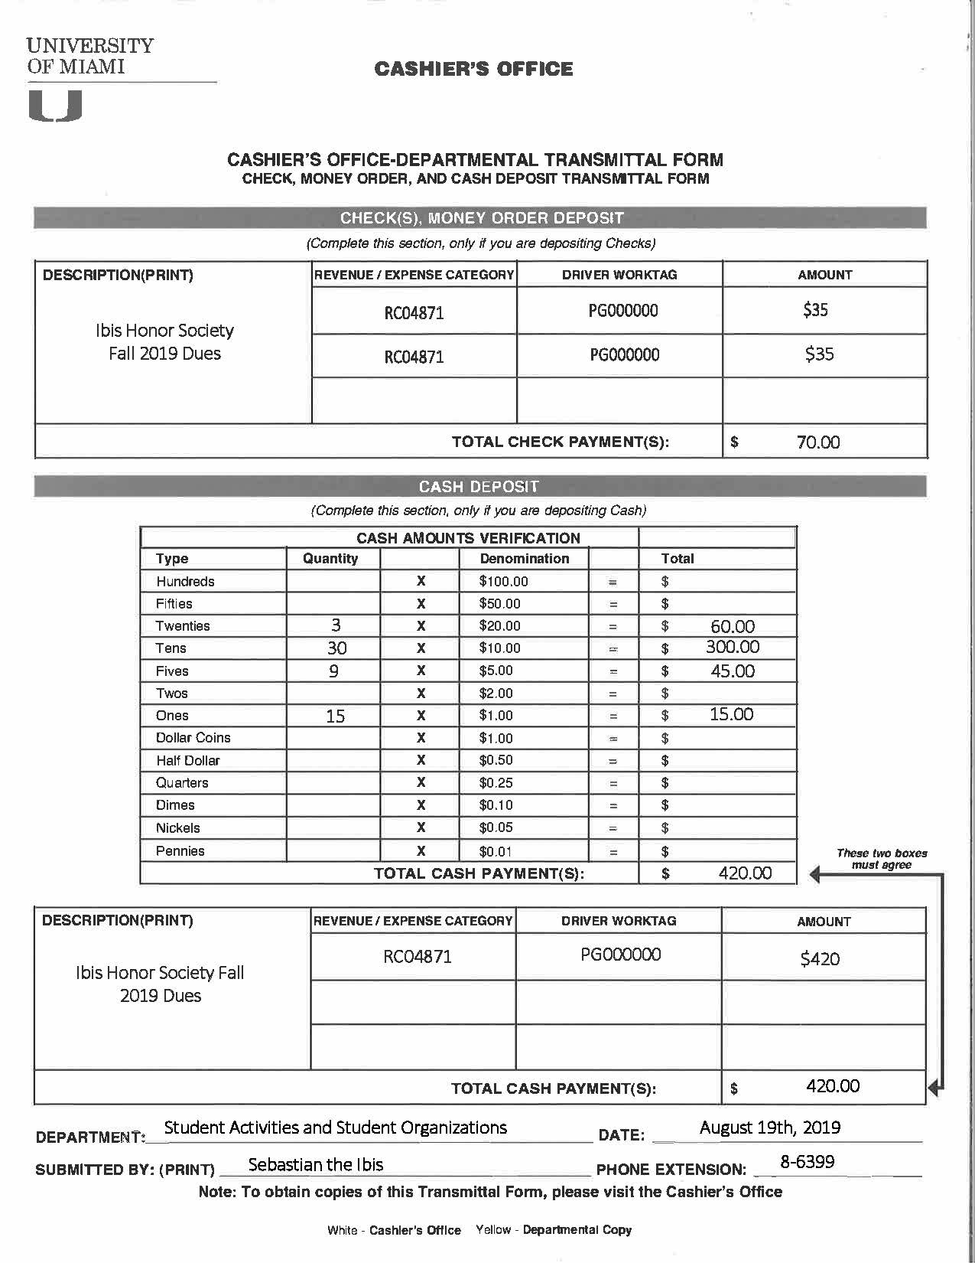

Provide your advisor’s University phone extension. Use 8-(last four digits of their telephone number)

As a COSO registered organization, you are a part of the Department of Student Activities and Student Organizations.

This section is filled out only if you **have cash to deposit.**

Provide a brief description of the funds being deposited.

This is the total monetary value all checks being deposited.

Name of the person depositing the funds.

This section is filled out only if you are **depositing a check(s)**.